BitBot Robotic Project

# Project Description

The BitBot is a simple robotics/embedded systems project that utilized motor control, an accelerometer, and a gyroscope to control the movement of the bot. There are two parts to the robot. There is the main robot body, and the glove controller.

The main body of the robot is a cylinder with two wheels on either side (hence the name, BitBot). The body of the bot, as well as the wheels, were 3D modelled and printed using the Ender3 Creality 3D printer. The chassis for the controller of the bot was also 3D modeled and printed the same way. The controller is attached to a glove, and is used to determine the orientation of your hand in order to control the movement of the BitBot.

## Parts

* [ESP32 WROOM DevKit](https://www.amazon.com/dp/B08D5ZD528?psc=1&ref=ppx_yo2ov_dt_b_product_details) x2
* Wires
* Solder
* Miscellaneous 3D printed parts

Controller:

* [MPU6050 3 Axis Accelerometer Gyroscope Module](https://www.amazon.com/dp/B00LP25V1A?ref=ppx_yo2ov_dt_b_product_details&th=1) x1
* [Adafruit Powerboost 500c](https://www.amazon.com/dp/B00PY2YTVU?psc=1&ref=ppx_yo2ov_dt_b_product_details) x1
* [Slide Switch](https://www.amazon.com/dp/B09R434VJQ?ref=ppx_yo2ov_dt_b_product_details&th=1) x1
* [3.7V 700mAh Lipo Battery](https://www.amazon.com/dp/B07TS8N25G?psc=1&ref=ppx_yo2ov_dt_b_product_details) x1
* [Prototype PCB (4cmx6cm)](https://www.amazon.com/dp/B07NM68FXK?psc=1&ref=ppx_yo2ov_dt_b_product_details) x1
* [Glove](https://www.amazon.com/dp/B07HG6VMQ9?ref=ppx_yo2ov_dt_b_product_details&th=1&psc=1) x1

Bot:

* [12V 1000RPM DC Motor](https://www.amazon.com/dp/B0745YDSJS?psc=1&ref=ppx_yo2ov_dt_b_product_details) x2
* [L298N Motor Driver](https://www.amazon.com/dp/B07WS89781?ref=ppx_yo2ov_dt_b_product_details&th=1) x1
* [Boat Rocker Switch](https://www.amazon.com/dp/B0BCJXJZZ7?ref=ppx_yo2ov_dt_b_product_details&th=1) x1
* [12V 2400mAh Li-Ion Battery](https://www.amazon.com/dp/B0C241NS29?ref=ppx_yo2ov_dt_b_product_details&th=1) x1
* [Rubber strips for wheel treads](https://www.amazon.com/dp/B08Y7NJJ5C?ref=ppx_yo2ov_dt_b_product_details&th=1)
* M3x0.5 Bolts x6

# Basic Design

The BitBot consists of the main body, as well as the controller. Both require housing and circuitry. Diagrams for both of these can be found below.

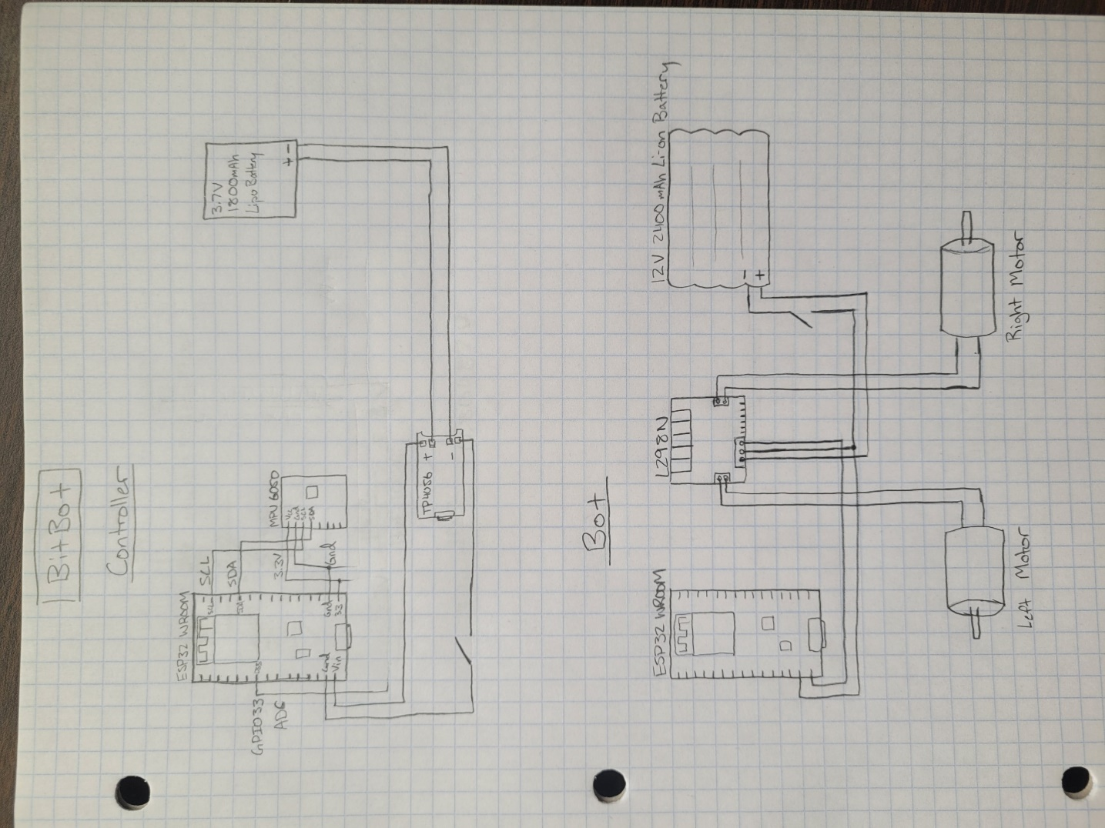

Figure 1: Basic Circuit Diagrams (control wires for bot not shown)

Figure 2: BitBot Bottom Body Figure 3: BitBot Top Body

Figure 4: BitBot Wheel

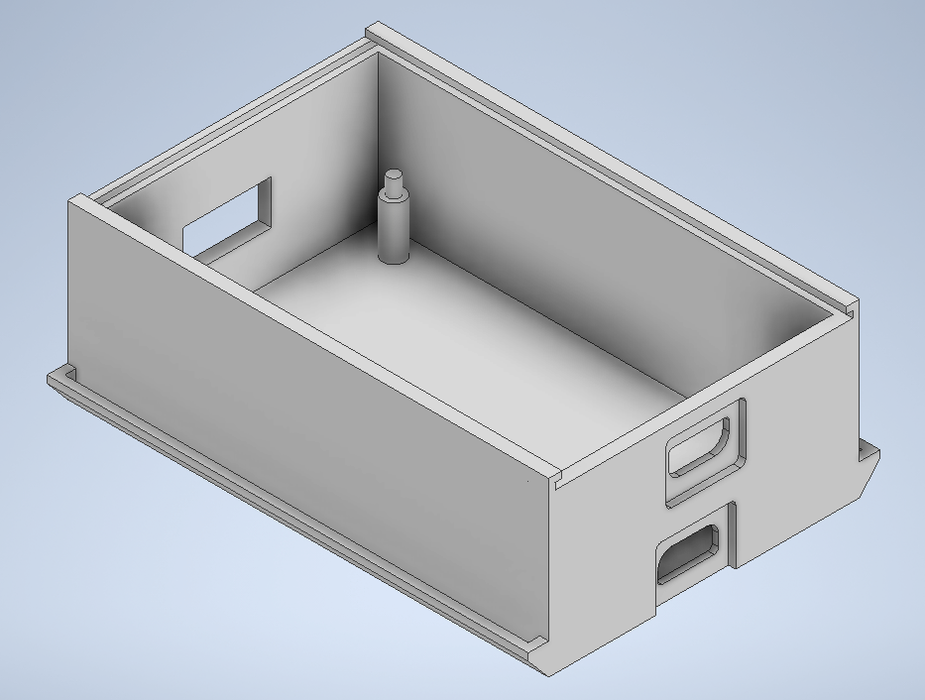

Figure 5: Controller Chassis Figure 6: Controller Lid

Figure 7: Controller Glove Clamp

The assembly is simple. The top of the BitBot body snaps into place on the BitBot Bottom Body. It may take some effort to get it in place, but it will go. Then, two wheels are used and attached to the shafts of each of the motors. The motors are attached to the body of the bot using the M3 bolts. After the parts are all put into the body, it will look like the image shown in Figure 8.

The controller is soldered together, and is placed into the Controller Chassis, which is used to house the controller’s system. The lid is slid over, and then that housing can be clamped to the archery glove, connecting the controller to the glove and allowing us to wear the glove and control the robot.

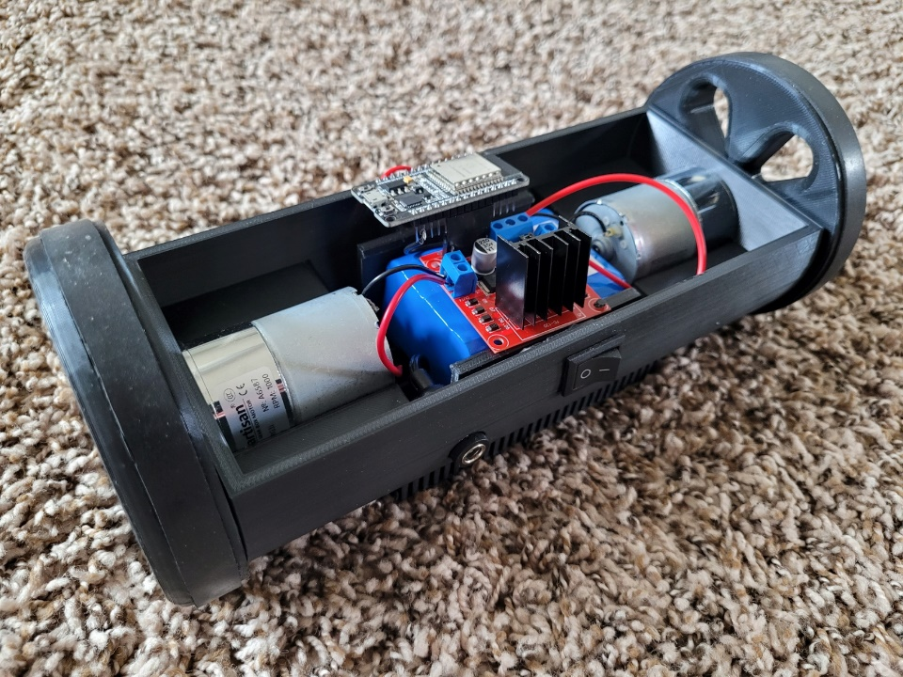

Figure 8: Completed BitBot without top

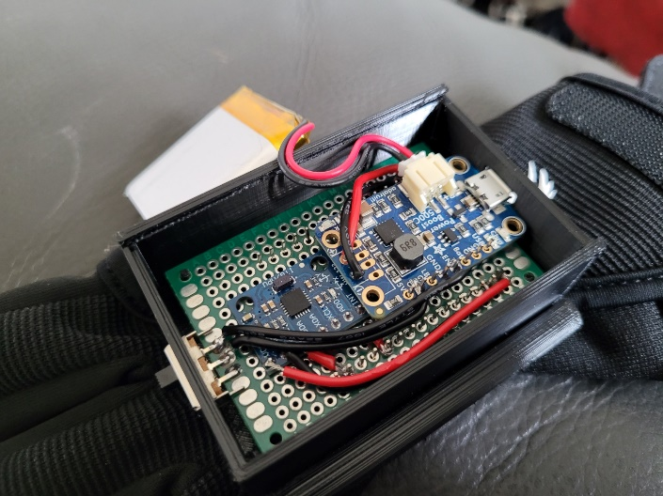 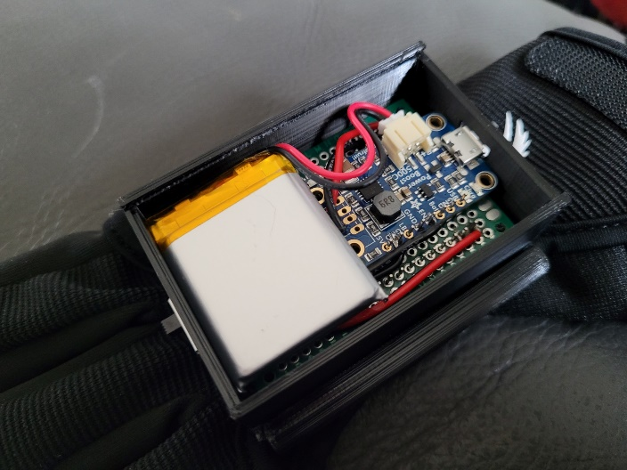

Figures 9 & 10: Controller circuit in housing, ESP32 soldered on bottom

The code for each of the boards can be uploaded either before or after the boards are soldered and put into their respective housings, though the actual bot’s ESP32 should be programmed before the top of the BitBot is put on. Then, both systems can be turned on, and after about 10 seconds of waiting, all calibration should be done, and the bot will connect to the controller, allowing you to use the motion of your hand to control the bot.

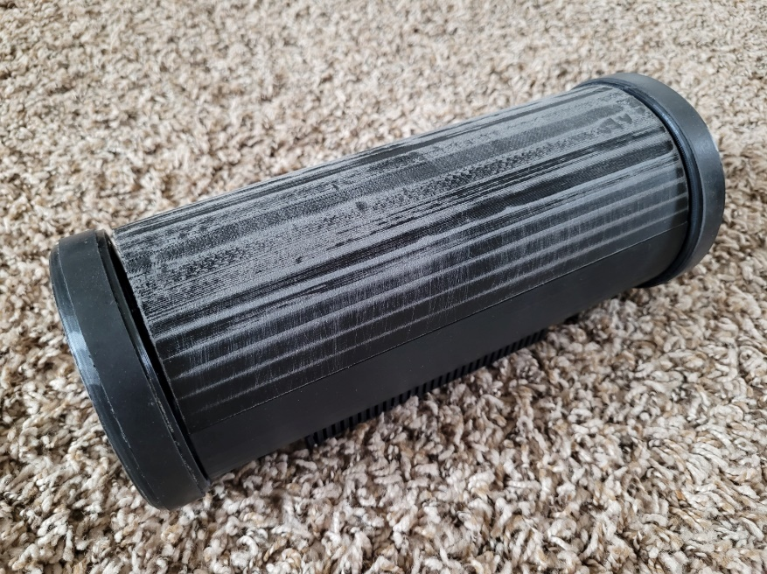 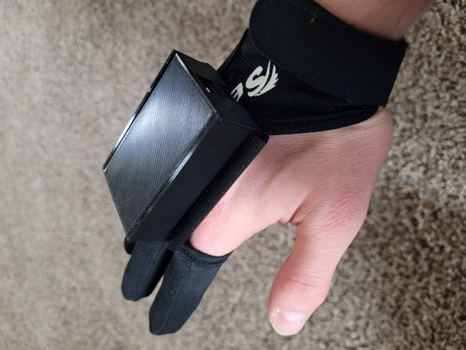

Figure 11: Completed BitBot Figure 12: Controller on Hand